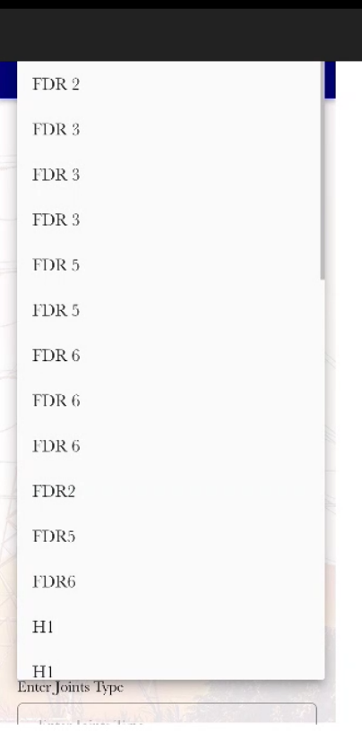

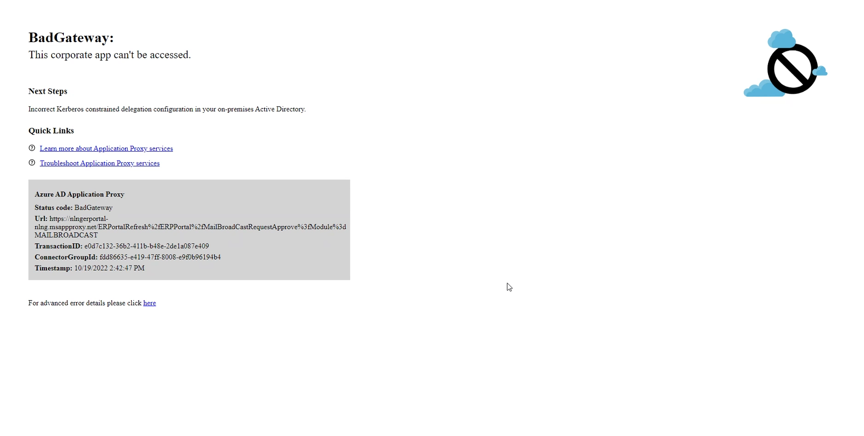

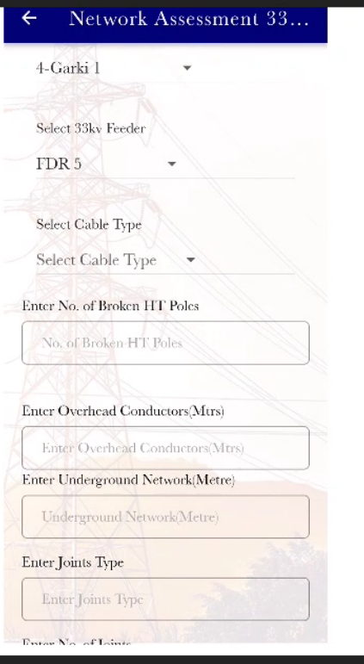

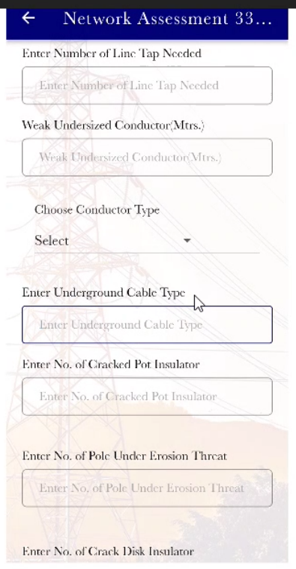

|  |  |  |
| --- | --- | --- |
|  |  |  |
| Enter Feeder Power Factor and  Enter Feeder Route Length  And Enter Feeder Peak Load  should come before Enter No of Broken HT Poles |  |  |
| Remove Switchyard Status |  |  |
| Enter Thermographic Camera Temperature (OC) |  |  |
| Remove |  |  |
|  |  |  |
|  |  |  |
|  |  |  |

|  |  |  |
| --- | --- | --- |
|  | **DTR ASSESSMENT** |  |
| Intermediate (Incomer) Cable Size (**mm**) |  |  |
| Remove Enter Joints Type  Remove Enter No of Joints |  |  |
| Correct to **Plinth** Status not ***PLINTCH*** |  |  |
| When you Selelct BAD, Show a text box to show the no that is BAD |  |  |
| Add is Equipment Vandalised? | YES or NO |  |
| Add A column is YES to capture |  |  |
|  |  |  |
| Comments on Vandalized | Textbox to Add the Comments |  |
| Change the name to Network Assessments Injection Substation |  |  |
|  |  |  |

|  |  |  |  |  |
| --- | --- | --- | --- | --- |
|  | **INJECTION SUBSTATION** | |  | |
| Change to **kV** not KV or kv |  | |  | |
| Enter Injection Substation ***Loading*** Capacity(%) | |  | |  |
| Enter Injection Substation 11KV Incomer Total Load (**MW**) | |  | |  |
| This should be a Drop down for GOOD or BAD | |  | |  |
| Enter TF Temperature (OC) | |  | |  |
| Enter Switchyard Status – This should be a dropdown for GOOD or BAD | |  | |  |
| Enter Thermographic Camera Temperature (OC) | |  | |  |
|  | |  | |  |
|  | |  | |  |
|  | |  | |  |
|  | |  | |  |
|  | |  | |  |
|  | |  | |  |
|  | |  | |  |
|  | |  | |  |
|  | |  | |  |
|  | |  | |  |
|  | |  | |  |